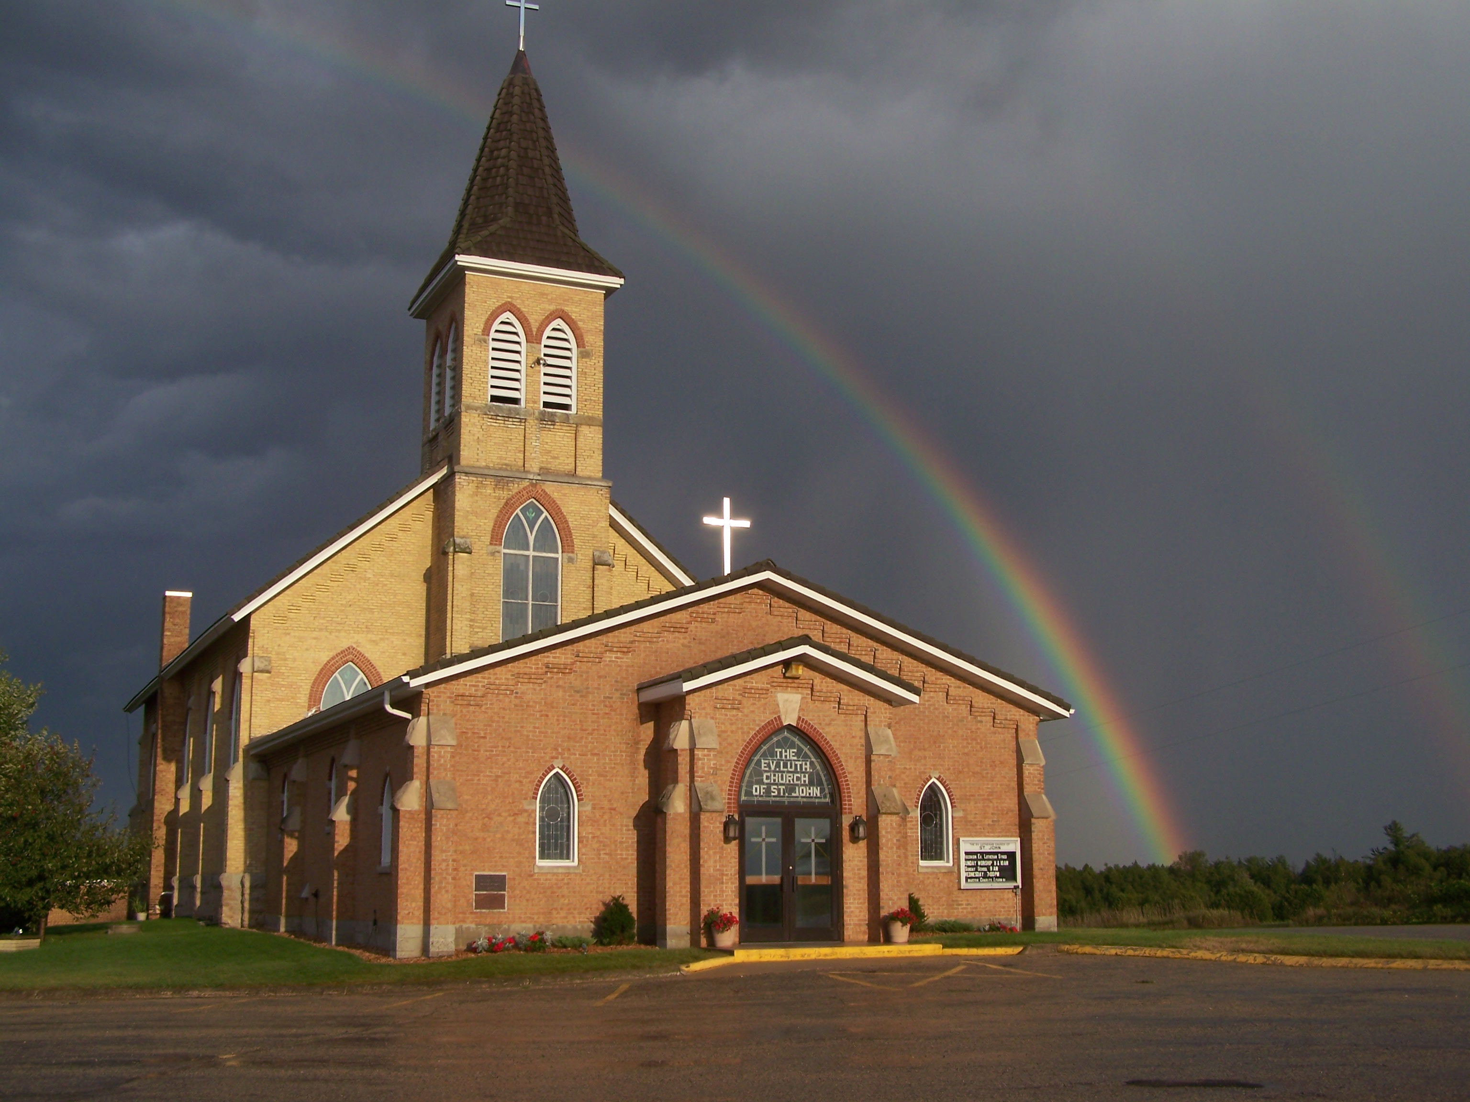
The Evangelical Lutheran Church of St. John
N1916 Church Road
Peshtigo, Wisconsin 54157-9673
Pastor Sargent 920-228-1061

08/27/2020
Dear members of St. John,
The School year has begun. We will be starting Sunday School on the 13th of September. Because of the current situation and the pandemic, the Church Council voted to hold
Virtual Sunday School. We are blessed that Northwestern Publishing House will be able to assist with this program.

The Christ Light Remote Learning program is a complete curriculum that combines teacher led lessons and engages parents in reinforcing the lessons in tangible ways with their children. Here are some specifics:
- NPH is producing Christ-Light Lesson Videos for grades PreK-K, 1-2, 3-4, and 5-6. The lessons for Sundays beginning September 13 will be recorded and taught by experienced WELS teachers and available via YouTube prior to each Sunday. The engaging and age-appropriate video-based lessons are free with no required password for access.
- Lesson Videos will include a brief introduction for parents along with the lesson’s aim, the truth that is being shared, and a relevant application for the child, followed by the Bible lesson for the week.
- Printed Christ-Light Sunday School Student Lessons will be used by parents to help facilitate learning with their child.
- Following the Lesson Video, parents will be encouraged to complete an activity related to the lesson with their child and to reinforce the Memory Treasure.
- Printed Student Lessons are available for each grade level as noted above. They are shrink-wrapped in packs of 13 lessons for each student. The current cycle is Year 2, Fall, starting with Lesson 1, the story of God’s creation of Adam and Eve.
We are asking parents to sign up their children after services on Sunday the 30th of August and the 9th of September. You can also contact Pastor at dsargentzambia@gmail.com or call 920-228-1061. Materials for the students will be ordered and paid for by the church. These will be made available to the parents on Sunday the 13th of September.
For more information see: https://online.nph.net/ss-remote

Worship
We will worship with no more than 100 people in attendance for each service. At this time, we will not need to sign up before services because we have not gone beyond the occupancy limit. If that happens, we will go to the sign up again.
Mask Mandate:
The Governor has issued a State-wide Mask Mandate for all public indoor meetings. We will be following this mandate during worship services. If you do not haver a mask one can be provided for you by an usher.
Note: Those with medical conditions or other sensory sensitivities that prevent someone from being able to wear a mask may be exempt according to the Mandate.
- There will be two services on Sunday at 8:30 and 10:00.
- We will worship with no more than 100 people in attendance for each service.
- We will have portions of the church pews partitioned off to accommodate social distancing. Please be sure to sit only in the apportioned sections. Ushers will guide you to your seat of choice.
- No hymnals will be used. All service materials will be printed in the church bulletin, handed out to each member by an usher wearing a mask and gloves.
- We will not be passing offering plates in the worship service but will have them at the doors of the sanctuary where you may drop your offering.
- When church is over you will be ushered out. Please don’t get up and leave on your own. That will make it difficult to keep proper social distancing.
- We are requiring that everyone wear a facemask and please remember social distancing.

Social Interaction

In order to maintain responsible social distancing, we are strongly encouraging the following:
- No physical contact: handshakes, hugs, fist bumps, etc.
- No gathering within church for socializing either before or after services.
- At this time all other church events, Bible Study, Sunday School, Ladies Aid and Quilting (etc.) will be on hold.

- If you are not feeling well or have concerns about your own health, you do not need to attend. We will continue with the Livestreaming service at 8:30. If you would like to receive private communion at home please contact Pastor Sargent.

http://www.facebook.com/The-Evangelical-Lutheran-Church-of-St-John-Town-of-Grover-WELS-100389558275581/
https://www.youtube.com/channel/UCJ8tkCadzLHuxGWLhovgl8Q
Reminder of Important Information:


Sunday School:
Signup sheets are in the back of Church for Sunday School. You can also contact Pastor Sargent at dsargentzmabia@gmail.com or 920-228-12061



Confirmation Class
We will begin confirmation class on Wednesday the 9th of September at 4:30. Please be reminded that student will be required to wear masks during class.

Livestreaming Volunteers:

We are looking for volunteers to help with the 8:30 service livestream broadcast. This is not a complicated program but needs volunteers who would be willing to learn to turn on the computer and press the needed buttons to start the live feed and move the camera during the service. Please contact Pastor is you are interested.


Pastor Daniel Sargent

